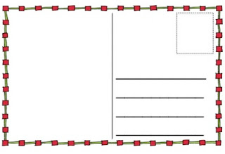

One goal I have for myself (something I want to do better):

This is what I will do to reach my goal:

This is what I want to do after high school:

This is what I will do to reach my goal: