The Nicolet Lake Incident
You are one of a small group of people returning from a fishing trip on Nicolet Lake in Wisconsin. At 4 o’clock in the morning on a cool winter day, there is a small explosion near the engine of your boat while you are still aboard. The engine is torn from its mountings and there is a huge hole in the bottom of the boat. Water is pouring in, and you have no way to control the flooding. The boat is sinking fast in deep water. You are miles from shore and the boat’s radio is broken from the explosion. The temperature of air and the water is very cold. The water temperature is just above freezing at 37 degrees Fahrenheit, and there is a cold wind blowing at 15 miles per hour. No one is hurt.
You have to think fast to survive! Your job is to decide what you are going to do and rank the items on the list in order of their importance to your survival. Remember that your group is in danger of drowning and hypothermia. You will not survive more than 60 minutes in water this cold and deep. Your group’s only hope for survival is to work together to stay out of the water and be rescued.
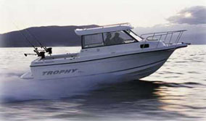

*Adapted from The Big Bear Lake Incident in:
Handrich, T., Schroeder, D. (2010). The ultimate middle school counseling handbook. Marco Products, Inc. Warminister: PA.

